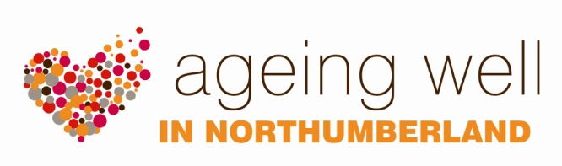

TRAINING

AGEING WELL ALLIES

This free, one day, training course is available to groups of workers and volunteers who have regular contact with older people through their work, especially at home. The Ageing Well Allies programme aims to gives workers the knowledge and confidence they need to signpost people (who would otherwise not engage or who are isolated), to support and social activity.

Learning outcomes:

- Understand how being an Ageing Well Ally can support your work.

- Knowledge of the key health improvement messages that support wellbeing e.g. healthy nutrition and hydration, physical activity, stopping smoking, emotional wellbeing and the early detection of diseases.

- Knowledge of safeguarding, key messages and information to keep people safe.

- Understand the role of unpaid carers and the support that is available for them.

- Understand how to help people access help and feel confident in signposting older people and others to a range of health and social care and community services for appropriate advice, information and support.

Follow up for Ageing Well Allies includes on-going regular information bulletins.

Being an Ageing Well Ally also gives individuals the opportunity to extend their learning to become a Health Champion, should they wish, or partake in a one day Royal Institute of Public Health accredited course, Understanding Health Improvement.

Ageing Well Allies training is available via:

- Sessions which are planned and advertised by the Ageing Well team.

- Sessions which are arranged by a specific organisation (e.g. for a staff or community group).

Want to know more?
For more information please contact Kay Yeo, Health Improvement Practitioner Specialist on 01670 629000 or email kay.yeo@ncht.nhs.uk

