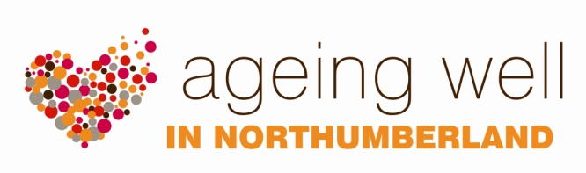
introduction

What is Ageing Well?
Ageing Well is a positive approach to planning and working with local people to ensure Northumberland is a good place in which to live, as we grow older. It seeks to promote the health and wellbeing of older people within their local communities while also valuing the skills, experience and energy people offer.
Ageing Well is a Northumberland County Council initiative, led by the involvement and service development team within adult community services. The team offers to work closely with individuals and existing local community groups, helping to link local activity, initiatives and people to quality public service advice and information, particularly around health, wellbeing and social support. By building upon the strengths of each local community we aim to ensure people, as their needs change due to age, are able to stay active, connected and well.
Background
Northumberland is the most northerly and sparsely populated county in England, with a population of just over 316,000 people divided between an urban South East corner and rural areas mainly in the North and West.
Northumberland is a special place – somewhere that retains a strong identity, stemming from the unique combination of its landscape, location and heritage.
Northumberland’s population continues to grow but the balance of the younger to older is changing more quickly than in other parts of the country.
In a political environment which portrays growing numbers of older people as an unsustainable burden for health and social care agencies, Ageing Well take an asset based approach which:
- starts with the assets in a community
- identifies opportunities and strengths
- invests in people as citizens
- emphasises society as a community of people who have a common interest
- focuses on communities/neighbourhoods and the common good
- sees people as citizens with something to offer
- helps people take control of their lives
- supports people to develop their potential
- sees people as the answer
The positive benefits of social connectedness for residents’ health and wellbeing has been well-researched and widely acknowledged.
Want to know more?
Please contact the involvement & service development team on 01670 629000

