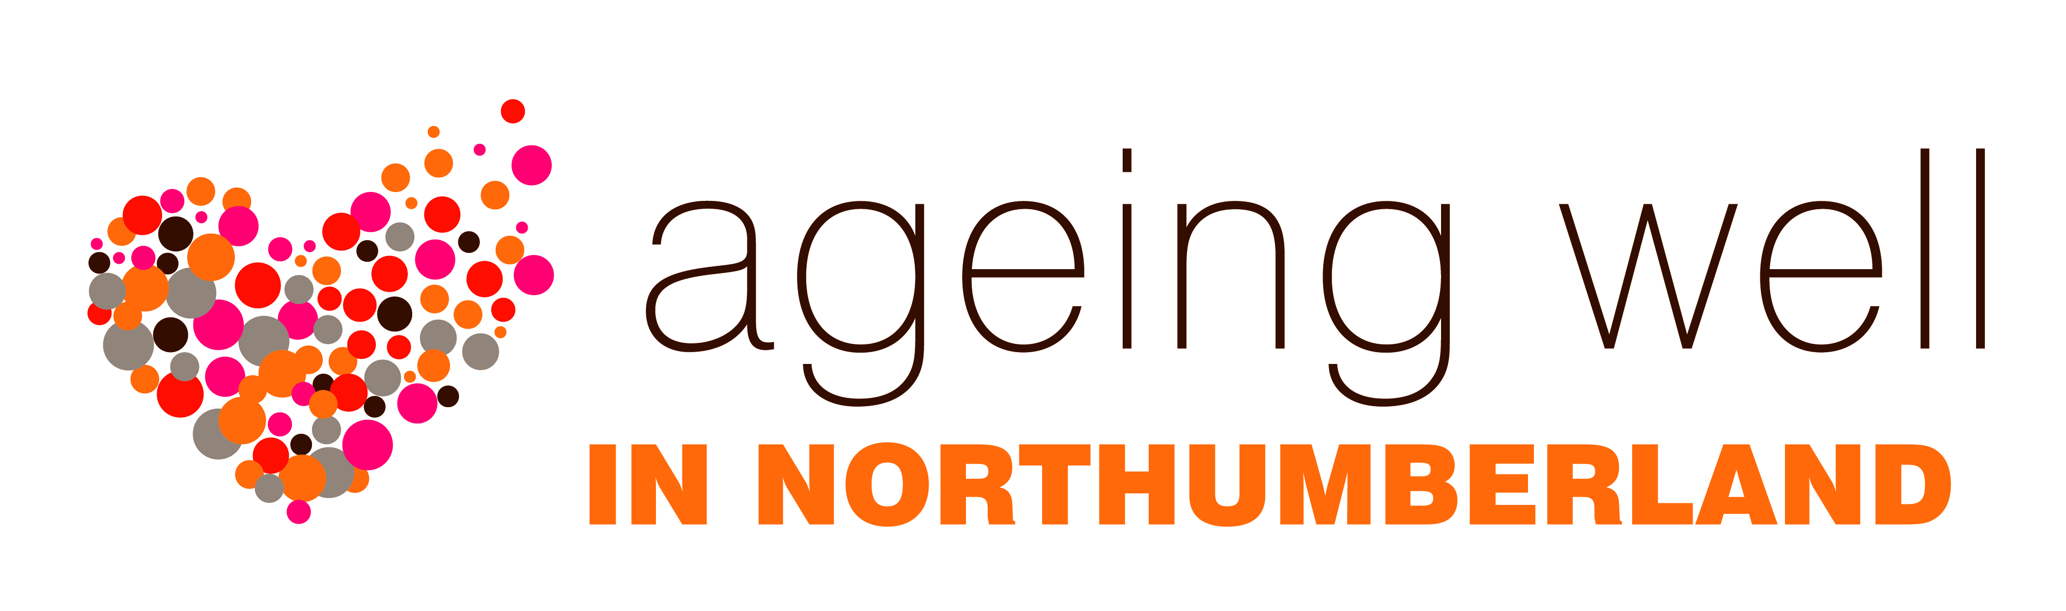
Welcome to the Ageing Well information pack

Ageing Well is a way of working with local people to ensure that Northumberland is a good place to live as we grow older. The image below is called the Ageing Well wheel and it highlights a number of key areas. The outer circle of the wheel shows where the people who are involved with Ageing Well come from: local communities as well as a variety of services and organisations which are part of public health, housing and planning, health and social care.

The values which underpin the Ageing Well concept are also listed around the perimeter of the wheel: staying connected, feeling included, staying healthy, working together, valuing experience, building on strengths and keeping safe.
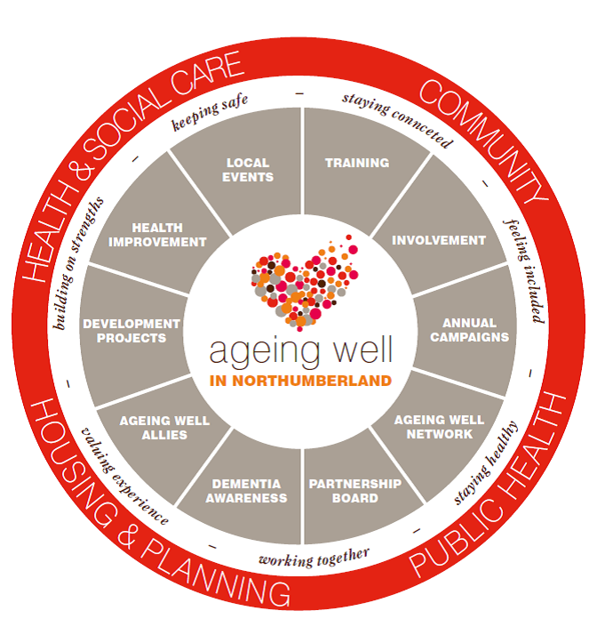

The segments of the wheel which surround the Ageing Well logo, highlight the main activities which are central to Ageing Well: local events, training, involvement forums, annual health campaigns, the Ageing Well network (which meets on a quarterly basis), the partnership board, dementia awareness, Ageing Well allies, development projects and health improvement.

The purpose of this information pack is to provide more information about Ageing Well (for anyone who might be interested in getting involved), particularly in relation to the activities which are shown on the segments of the wheel.

