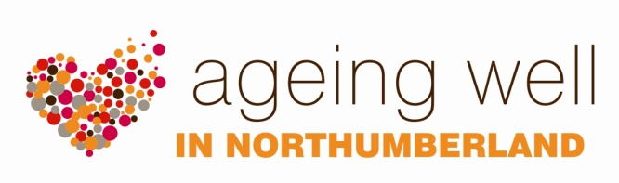
RESOURCES

HOW TO GET INVOLVED WITH AGEING WELL

Information and involvement forums

These forums are informal groups across Northumberland which are open to anyone enjoying later life, or caring for an older relative or friend. The forums aim to provide information and promote the health and wellbeing of people within their local community. Forum meetings are held every two months at Alnwick, Blyth, Morpeth and Hexham. At each session there is a main topic for discussion but attendees also receive updates about current local activities and have an opportunity to have a say in health or social care issues, as well as meeting a range of professionals that can help them. Additional time is taken to ensure that all the forum sessions are dementia friendly. Anyone who is interested in Ageing Well is welcome to attend the forum meetings. There is no need to book a place in advance. Professionals who work with older people are also very welcome to attend.

Ageing Well network

The Ageing Well Network exists in Northumberland to encourage partnership working and information sharing, particularly between statutory and voluntary sector professionals. It meets four times a year and anybody who has an interest in Ageing Well is welcome to come along to the meetings or join the distribution list to receive regular information updates. Network members are invited to share relevant information, either by attending the meetings or through an email cascade system. There are currently 97 organisations who are part of the Ageing Well network in Northumberland. Issues which have been identified at the local involvement forums can also be raised at the Ageing Well network and from there taken to the Ageing Well Partnership Board (if appropriate), which in turn feeds into Northumberland’s Health and Wellbeing Board. This process is illustrated in the governance diagram which is on page 8 of this information pack.

Want to know more?
For more information please contact Kay Yeo, Health Improvement Practitioner Specialist on 01670 629000 or email kay.yeo@ncht.nhs.uk

