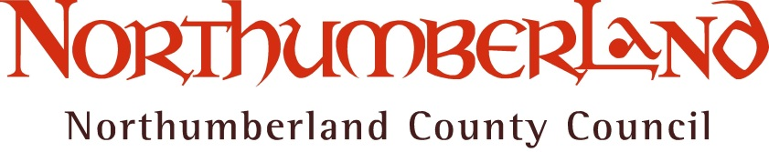

Consultation on proposed Admission Arrangements for community and voluntary controlled schools 2019/20

Overview

All schools must have admission arrangements that set out clearly how children will be admitted to schools, including sixth forms. Admission arrangements must include the criteria that will be applied if there are more applications for a school than there are places available. Northumberland County Council is the admission authority for all community and voluntary controlled schools in Northumberland.

Why are we consulting?

The Admissions Code 2014 requires admission authorities to consult on their admission arrangements once every seven years even if there are no changes proposed. This consultation will apply to the admission arrangements for entry into schools, including sixth forms, in September 2019.

Further information can be found on the DfE webpage, please refer to the School Admissions Code at:
https://www.gov.uk/government/uploads/system/uploads/attachment_data/file/389388/School_Admissions_Code_2014_-_19_Dec.pdf

We would like to hear your views on the following:

- Proposed Admission Arrangements, including proposed over subscription criteria and proposed admission numbers, for First and Primary Community and Voluntary Controlled schools 2019/20
- Proposed Admission Arrangements, including proposed over subscription criteria and proposed admission numbers, for Community and Voluntary Controlled Middle, High, Secondary schools and Sixth Forms 2019/20
- Proposed co-ordinated admission scheme for maintained schools and academies 2019/20 (this details the arrangements in place for all admission authorities in the area to enable places to be offered by the local authority at any school in its area and in other local authority areas).

If you have any comments please email these to Jane Jack, School Place Planning and Admissions Manager:

school.admissions@northumberland.gov.uk

Or write to:

Northumberland County Council
Wellbeing and Community Health Service
School Organisation and Planning
School Admissions
County Hall
Morpeth
Northumberland
NE61 2EF

A six week consultation is now open and runs from 16 October 2017 to 26 November 2017

Following the outcomes of consultation, the admission arrangements for 2019/20 for community and voluntary schools will be finalised by the Council in February 2018.

