CONSULTATION ON EDUCATION IN BELFORD

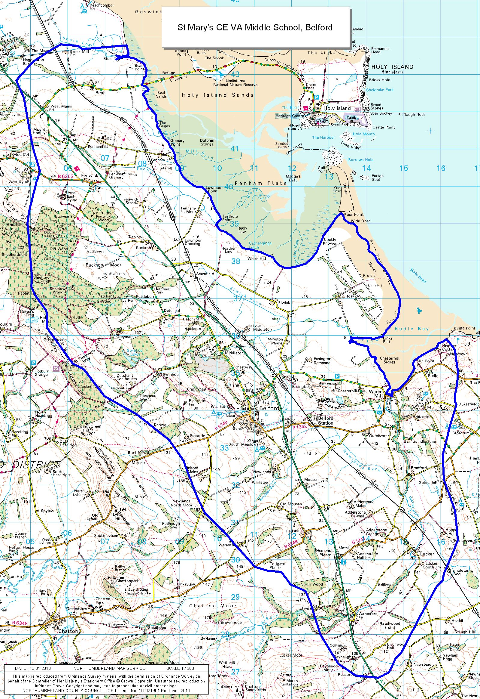

13 September – 1 November 2017
CONSULTATION ON
AUTUMN 2017

Northumberland County Council is consulting on proposals for the organisation of education in Belford. This follows on from consultation undertaken by the Governing Body of St Mary’s CE Middle School in February/March 2017. At that point, a number of alternative proposals were put forward by parents and members of the community and the Governing Body agreed to postpone any decision at that point in order to fully consider the alternatives.
Having considered the options, the Governing Bodies of both St Mary’s CE Middle School and Belford First School have asked the Council to consult on the following options for the organisation of education in Belford:
Option A –
- Close St Mary’s CE Middle School with effect from 31 August 2018;
- Extend the age range of Belford First School to include Years 5 and 6 from 1 September 2018. The school would become a primary school and would educate children up to age 11;
- Alter the catchment area of Berwick Middle School to incorporate the St Mary’s catchment for children for Years 7 and 8 only from September 2018 onwards.
Option B -
- Make no changes to the current arrangement of schools in Belford i.e. maintain the status quo.

The Council and the Governing Bodies of St Mary’s CE Middle School and Belford First School would like to find out what you think about the options outlined in this document and also whether you have any alternative ideas.
The feedback from this consultation will then be taken to the Council’s Cabinet for a decision on next steps.

WHY IS CONSULTATION ON CHANGING THE ORGANISATION OF SCHOOLS IN BELFORD TAKING PLACE?

Introduction

In February 2017, the Governing Body of St Mary’s CE Middle School came to the conclusion that it was becoming increasingly difficult to continue to provide a high quality, broad and balanced curriculum to students due to the difficult financial position of the school. The Governing Body therefore reluctantly initiated a consultation on the proposed closure of the school. Following feedback from parents and other consultees, the Governing Body concluded that it would not be appropriate at that point to continue with the proposal to close the school, but instead decided that it would be in the best interests of the students to put aside the closure process in order to fully explore the other options put forward. In particular, this included an option to provide primary education in Belford.

The Governing Bodies of St Mary’s and Belford First Schools have been in discussions about alternative education provision in the village and have asked the Council to carry out consultation on the options available to the schools, based on the feedback from the first consultation.

As a result, consultation is now being carried out on two options for educational provision in Belford.

Background

In the consultation carried out in February/March 2017, the Governing Body of St Mary’s set out their reasons for proposing closure of the school, and these reasons remain.

St Mary’s has had a significant fall in pupil numbers at the school in September 2017. There were 90 pupils on roll at the school in May 2017 and there are now 41 pupils on roll in September 2017; 14 pupils have joined the school this September in Year 5; the school’s Planned Admission Number (PAN) is 30 and it has the capacity for 120 pupils.
Schools receive a budget based on the number of pupils it has on roll, and not the size of the school. Therefore as pupil numbers fall, it becomes increasingly difficult for the Governing Body and staff to provide a broad and balanced curriculum due to the impact on staffing and teaching resources. As the staffing budget is the most significant cost to a school, it is generally this budget that has to be reduced as the budget fall.

Furthermore, middle schools in Northumberland are deemed to be secondary schools and with a reduction in staff, it becomes increasingly difficult to provide students in Years 7 and 8 in small middle schools with the secondary education equivalent to their peers. Sufficient educational, social, emotional and cultural experiences also become harder to provide to ensure that students achieve their full academic potential. However, the school must also continue to be heated, cleaned, lit and maintained to the same level, no matter how many students attend and therefore these costs never diminish.

In February/March, the Governing Body of St Mary’s also highlighted that it had received a letter from the Regional Schools Commissioner at the Department for Education (DfE) which stated that the school had been identified as a “coasting” school. This means that the students’ academic performance had not improved over 3 years. To address the issues identified, the school would need additional resources to improve; given the school’s increasingly difficult financial position, it will be extremely difficult to make the improvements required as the school already struggles to recruit new, high quality and specialist staff.

Option A

Proposal:
- Close St Mary’s CE Middle School with effect from 31 August 2018;
- Extend the age range of all Belford First School to include Years 5 and 6 from 1 September 2018. The school would become a primary school and would educate children up to age 11;
- Alter the catchment area of Berwick Middle School to incorporate the St Mary’s catchment for children for Years 7 and 8 only from September 2018 onwards.

During the first consultation run by the Governing Body of St Mary’s, a number of parents and community members put forward an alternative proposal that would see Belford First School extend its age range to become a primary school and provide education for children from age 4 to 11 in the village. This proposal has now been considered as an option by officers at the Council and the Governing Bodies of the two schools, and they are seeking your views on the proposal.

Under the proposal, St Mary’s would close as previously proposed, but not until 31 August 2018. Belford First School would extend its age range to include Year 5 and 6, with the retention of Year 5 (current year 4) on 1 September 2018. It is also proposed that the current Year 5 pupils in St Mary’s who have joined the school this September, would join the roll of Belford Primary School (as it would be) in September 2018; St Mary’s and Belford First schools are already working very closely together and will continue to do so, therefore it’s envisaged that this proposal for the Year 6 cohort in September 2018 would be the least disruptive for those pupils.

The catchment area of Berwick Middle School would be expanded to incorporate the catchment area of St Mary’s for students in Years 7 and 8; and students who would have been in Year 7 and 8 in St Mary’s in September 2018 would transfer to this school or to another school providing education in those year groups according to parental preference.

Option B
Proposal:
Make no changes to the current arrangement of schools or current system of school organisation within Belford i.e. maintain the status quo.

With regard to this proposal, it should be borne in mind that the Governing Body of St Mary’s has already consulted earlier this year on the proposed closure of the school for the reasons set out earlier in this document. Since that time, the number of pupils on roll has fallen dramatically from 90 to 41 as predicted. Therefore, the long-term viability of this option at this point in time should be considered.

Structure of the schools under Option A and timeline for implementation

Proposed timeline

31 August 2018
- St Mary’s CE Middle School would close.

1 September 2018
- Pupils in Year 8 in the middle school in August 2018 would transfer as Year 9 as usual to a local high school according to parental preference.
- Pupils in Year 6 and 7 in the middle school in August 2018 would transfer to join the Year 7 and 8 cohort at Berwick Middle School or to another school providing education in those year groups according to parental preference.
- Pupils in Year 5 in the middle school in August 2018 would join the roll of Belford Primary School (as it would be) as the new Year 6.
- Pupils in Year 4 in Belford First School in August 2018 would remain in the school as it becomes Belford Primary School as the new Year 5.

OTHER IMPLICATIONS OF THE PROPOSAL
Staff
There would be implications for staff in St Mary’s CE Middle School as a result of these proposals. Detailed discussions with the Governing Body the school and with the Trades Unions would be undertaken about how any adverse implications of the proposals for staff could be minimised.

Admissions and pupil transition
It would be proposed that pupils in Year 5 at St Mary’s in August 2018 would transfer to the roll of Belford Primary School (as it would be). The other feeder first school to St Mary’s is Lowick CE VC First School, which also feeds to Berwick Middle School, therefore for continuity it is proposed that Years 6 and 7 at St Mary’s in August 2018 would transfer to Berwick Middle School into Years 7 and 8 in September 2018. Year 8 in St Mary’s in August 2018 would transfer as normal into Year 9 at a local high school in September 2018.

It is proposed that pupils in Year 4 in Belford First School in August 2018 would remain on the roll of the school as they transfer into Year 5 in September 2018. It is also proposed that the current Year 5 in St Mary’s would join the roll of Belford Primary School (as it would be) in September 2018; the headteachers at both schools are already working closely and would ensure that any transition between the two schools would be as seamless as possible.

From September 2019, it would be expected that pupils leaving Belford Primary School at the end of Year 6 would join Berwick Middle School for Year 7 onwards. In any event, parents would continue to be able to exercise parental preference in relation to alternative schools for their children should the proposals be implemented.

Catchment Areas

Should St Mary’s be approved for closure, it would be proposed that the catchment area of the school would be incorporated into the catchment area of Berwick Middle School with respect to pupils in Years 7 and 8 only. The catchment area of Belford Primary (as it would be) mirrors the catchment of St Mary’s and would therefore remain as it is currently, but would be shown to be the catchment school for pupils living in that area up to the end of Year 6.

Again, changes to catchment areas would not preclude parents from exercising their parental preference to apply for a place for their child at any school should they wish to do so.

Early Years

Belford First School has nursery classes for children aged 2 to 4 and this provision would continue should the school expand to include Years 5 and 6.

School Transport

Transport for pupils affected by the proposals, should they be approved, would be arranged in accordance with the Council’s Home to School Transport Policy on an individual basis. In general, eligible pupils are transported to their catchment or nearest school by distance as calculated by the School Transport Team.

Special Educational Needs (SEN)

There is no specialist SEN provision currently within either St Mary’s or Belford First School and therefore there would be no impact on this provision should Option A be implemented.

Implications for school buildings

If Option A is approved for implementation, St Mary’s CE Middle School would close and statutory education would cease to be provided from that building. Primary education would be provided from the current Belford First School site. The St Mary’s school building is owned by Newcastle Diocesan Education Board, while the playing field is owned by the County Council. As part of this consultation, we are seeking your views on any alternative proposals you may have for the use of the building and playing field.

Sport and Recreation

Under Option A, sport and recreation would continue to be provided as part of the primary curriculum. However, if you have any specific comments relating to the provision sport and recreation in school in Belford, then you can put forward your comments or views as part of the consultation process.

HOW CAN I MAKE MY VIEWS ABOUT THESE PROPOSALS KNOWN?

The Council and the Governing Bodies of St Mary’s and Belford First School would like to hear your views on the options for the organisation of education in Belford set out in this document, including whether you have any alternative proposals that could address the issues raised. A response form is attached for your use at the back of this document. The form can either be sent by Freepost or attached electronically to an email – contact details are provided on the form. Alternatively, you can hand in your forms to a member of staff at either St Mary’s or Belford First School.

Consultation is open until midnight on 1 November 2017. In addition to completing the form, you may wish to attend the consultation event on the following date:

- Wednesday, 11 October, 3.30 p.m. – 7.00 p.m.
Venue - St Mary’s CE Middle School, Belford

Council Officers and representatives from the schools will be on hand at the event to answer your questions and receive your feedback on the proposals.

In addition, the Governing Bodies will be holding separate meetings with the staff at their schools, which will also be attended by Council Officers and staff representatives. The dates of these meetings will be arranged separately with the schools.

WHAT HAPPENS TO THE FEEDBACK FROM CONSULTATION?
Following the review of all feedback received from consultees, the Council’s Cabinet will meet in December to decide whether or not to proceed to the next step in the process; if the decision is to proceed with Option A, then a statutory proposal would be published for four weeks and if the decision is for Option B, no change then the process would end at that point.

Electronic copies of the consultation document and an online consultation response form are available from the Council’s website (address below). If you would prefer a paper copy of the consultation document, then please call 01670 623417:

www.northumberland.gov.uk/schoolconsultations

CONSULTATION RESPONSE FORM
VIEWS ON PROPOSED OPTIONS FOR EDUCATION IN BELFORD

PART 1- ABOUT YOU

Your name (Optional):

Your postcode:

Are you a Northumberland resident? YES NO

Are you responding mainly as a (tick one box only):

Parent/carer: Governor:

Staff Member: Pupil:

If you ticked any of the above, with which school or schools are you associated?

If none of the above: please specific whether you are a:-

Local Resident: Town or village in which you live:

Parish Councillor: Parish/town council:

Other: Please clarify:

Please now continue to the questions overleaf.

PART 2 – YOUR VIEWS ON THE PROPOSED OPTIONS

1) Do you believe that St Mary’s CE Middle School should close with effect from 31 August 2018 and that Belford First School should extend its age range to include Years 5 and 6 from 1 September 2018?

Yes No Don’t know/
Not applicable
Your reasons for ticking the above (Please continue on a separate sheet if necessary).

2) Do you believe that St Mary’s CE Middle School and Belford First School should continue as they are currently organised?

Yes No Don’t know/
Not applicable

Your reasons for ticking the above (Please continue on a separate sheet if necessary).

3) If you answered ‘Yes’ to Question 1, do you agree that the catchment area of St Mary’s CE Middle School should be allocated to Berwick Middle School for Years 7 and 8?

Yes No Don’t know/
Not applicable

Your reasons for ticking the above (Please continue on a separate sheet if necessary).

4) If you answered ‘Yes’ to Question 1 and you have any views or comments on what should happen to the St Mary’s school building and playing field, should the school be approved for closure, then please write them below

5) If you have any further comments on any of the issues within this document, please write them below:

PART 3 – ALTERNATIVE MODELS

6) If you have an alternative suggestion to any of the options set out in this document that would deal with the issues raised, please set it out below.
(please continue on a separate sheet if necessary).

THANK YOU FOR TAKING PART IN THIS CONSULTATION

Now please return your Response Form to:
FAO Lorraine Fife, Children’s Services, FREEPOST MP135, County Hall, MORPETH, NE61 1BR
Or send your response electronically to:
email Lorraine.Fife@northumberland.gov.uk

