National Funding Formula : Update and Consultation

Q1 The Department for Education (DfE) have decided that Local Authorities will move to a National Funding Formula (NFF), or “Hard Formula” by 2020/21. A comparison of the respective formula values is shown in the table below.

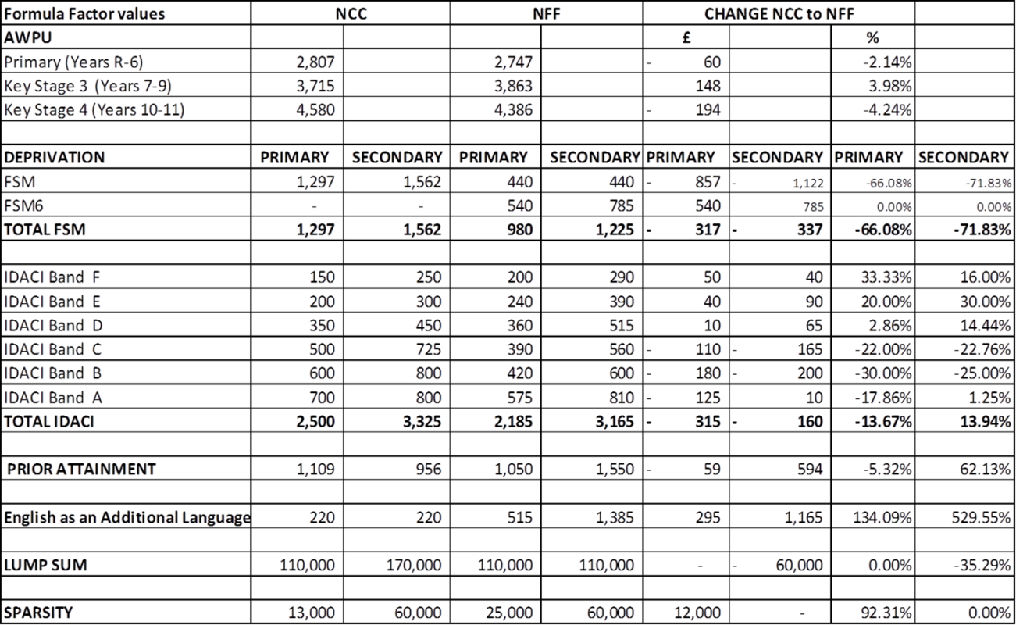

Given the anticipated requirement to move to NFF values by 2020/21, we would welcome your views on how Northumberland should approach this over the next two years. Should we :

☐ Immediately adopted the National Funding Formula values, subject to any adjustments arising due to Minimum Funding Guarantee with effect from 2018/19.

☐ Move towards NFF values in a phased approach over 2018/19 & 2019/20 prior to the full adoption of NFF in 2020/21, with some compensating adjustments to Primary and KS4 age weighted pupil units, according to affordability. This is the preferred solution at this stage and was supported at Schools’ Forum on 14 November 2017.

SEN Update
Q2 Northumberland has significant pressures on its Special Education Needs (SEN) expenditure, funded via the High Needs Block. Among these key pressures as reported to Schools forum are :
- Top Up Funding;
- Independent Sector and Out of County placements;
- The need to invest in new capacity in our special schools to reverse the increasing number of out of county placements.

- No increase in High Needs Block funding has been allocated for 2018/19. Given these pressures Northumberland County Council is seeking agreement to transfer 1.0% from the Schools Block to the High Needs Block.

Do you agree to the Council’s proposal to transfer 1.0% from the Schools Block to the High Needs block?

☐ Yes
☐ No

Please use the box below for any other comments that you have in relation to the NFF Consultation Exercise:

Further supporting information, and a copy of this consultation document, is available on the Council website at:
http://www.northumberland.gov.uk/Education/Schools/Consultations.aspx#schoolconsultations

This includes:

- November 2017 Schools Forum report on the National Funding Formula
- Illustrative Funding allocation for individual schools for 2018/19 though please note these will be subject to adjustment following the confirmation of October 2017 School Census information.
- November 2017 Schools Forum report on Special Educational Needs (SEN)

Please return all completed questionnaires to:
(OPTIONAL) Name and Email address of person completing consultation:
Name : ___________________

Email : ___________________

Bruce Parvin
Education and Skills Manager
Education and Skills Service
Wellbeing and Community Health Services Group
Northumberland County Council
County Hall
Morpeth
NE61 2EF

Email : bruce.parvin@northumberland.gov.uk

All responses to be returned no later than 12.00 noon on Friday 24 November 2017. Due to reporting deadlines in line with Department for Education requirements for the submission of information by the end of the month, consultations received after this closing date will not be considered.

