Index Number: | No. 4.04
Document: | NSCB Multi-Disciplinary Training Programme  April 2015 – March 2016
Approved by: | NSCB Main Board, March 2015
Date Published: | March 2015
Review Date: | October 2015
Lead Officer: | Robin Harper-Coulson
Description: | Evaluation of multi-agency safeguarding training and the LSCB training strategy

NORTHUMBERLAND
SAFEGUARDING CHILDREN BOARD

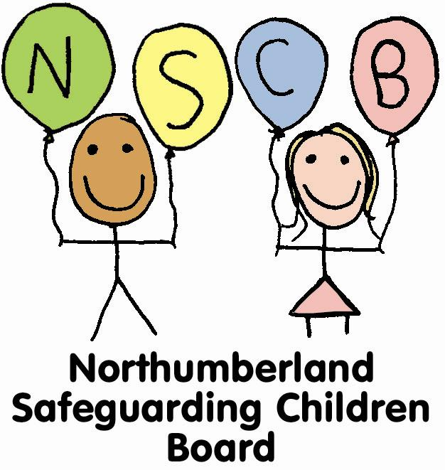

Multi-Disciplinary Training Programme
April 2015 – March 2016

Multi Agency Training Programme Calendar 2015-16 – Year at Glance
Date / Time | Course Title / Venue | Target Group(s)
15 April 2015  09:30 – 16:30 | Neglect  Prudhoe Fuse Centre, Prudhoe | 2-4
17 April 2015  09:30 – 12:30 | Child Sexual Exploitation  West Hartford Fire Station, Cramlington | 2-4
22 April 2015  09:30 – 16:30 | Impact of Parent Mental Health on Parenting  West Hartford Fire Station, Cramlington | 2-4
23 April 2015  09:30 – 16:30 | Multi-Agency Child Protection  West Hartford Fire Station, Cramlington | 2-4
8 May 2015  09:30 – 12:30 | Vulnerable Adolescents  West Hartford Fire Station, Cramlington | 2-4
12 May 2015  09:30 – 12:30 | Learning Lessons from Case Reviews  West Hartford Fire Station, Cramlington | 1-8
14 May 2015  09:30 – 16:30 | Sexual Abuse  North Tyneside venue | 2-4
18 May 2015  09:30 – 12:30 | E-Safety  West Hartford Fire Station, Cramlington | 2-4
20 May 2015  09:30 – 12:30 | Physical Abuse  West Hartford Fire Station, Cramlington | 2-4
3 June 2015  09:30 – 16:30 | Multi-Agency Child Protection  Bell View, Belford | 2-4
4 June 2015  09:30 – 16:30 | Safeguarding Disabled Children  North Tyneside venue | 2-4
8 June 2015  13:00 – 16:30 | Self Harm  West Hartford Fire Station, Cramlington | 2-4
15 June 2015  13:30 – 16:30 | Sexual Exploitation  West Hartford Fire Station, Cramlington | 2-4
17 June 2015  09:30 – 13:00 | Introduction to Attachment  West Hartford Fire Station, Cramlington | 2-4
25 June 2015  10:00 – 12:00 | Signs of Safety Briefing  West Hartford Fire Station, Cramlington | 2-4
29 June 2015  09:30 – 16:30 | Working with Resistant and Unco-operative Parents  West Hartford Fire Station, Cramlington | 6
30 June 2015  09:30 – 16:30 | Working with Resistant and Unco-operative Parents  West Hartford Fire Station, Cramlington | 6
7 July 2015  09:30 – 16:30 | Emotional Abuse  West Hartford Fire Station, Cramlington | 2-4
8 July 2015  09:30 – 12:30 | Safeguarding Children from Extremism  West Hartford Fire Station, Cramlington | 2-4
9 July 2015  09:30 – 12:30 | Impact of Domestic Abuse  Bell View, Belford | 2-4
10 July 2015  09:30 – 12:00 | Safeguarding Trainers Quality Assurance Forum  West Hartford Fire Station, Cramlington | 5
16 July 2015  09:30 – 16:30 | Adult Perpetrator of Sexual Abuse  West Hartford Fire Station, Cramlington | 2-4
7 & 8 Sep 2015  09:30 – 16:30 | Signs of Safety 2 day Course  West Hartford Fire Station, Cramlington | 3-4
9 September 2015  09:30 – 13:00 | Self Harm  Bell View, Belford | 2-4
11 September 2015  09:30 – 16:30 | Neglect  West Hartford Fire Station, Cramlington | 2-4
15 September 2015  09:30 – 16:30 | Multi-Agency Child Protection  West Hartford Fire Station, Cramlington | 2-4
17 September 2015  09:30 – 12:30 | Child Sexual Exploitation  Prudhoe Fuse Centre, Prudhoe | 2-4
22 September 2015  09.30 – 16:30 | Undertaking Section 47 Enquiries  West Hartford Fire Station, Cramlington | 4
23 September 2015  13:30 – 16:30 | E-Safety  West Hartford Fire Station, Cramlington | 2-4
30 September 2015  09:30 – 12:30 | Learning Lessons from Case Reviews  West Hartford Fire Station, Cramlington | 1-8
6 October 2015  09:30 – 16:30 | Sexual Abuse  West Hartford Fire Station, Cramlington | 2-4
8 October 2015  09:30 – 12:30 | Fabricated or Induced Illness  West Hartford Fire Station, Cramlington | 2-4
13 October 2015  09:30 – 12:30 | Impact of Domestic Abuse  West Hartford Fire Station, Cramlington | 2-4
15 October 2015  09:30 – 16:30 | Impact of Parental Mental Health on Parenting  West Hartford Fire Station, Cramlington | 2-4
20 October 2015  09:30 – 12:30 | Vulnerable Adolescents  West Hartford Fire Station, Cramlington | 2-4
3 November 2015  09:30 – 12:30 | Child Sexual Exploitation  West Hartford Fire Station, Cramlington | 2-4
6 November 2015  09:30 – 16:30 | Multi-Agency Child Protection  West Hartford Fire Station, Cramlington | 2-4
9 November 2015  09:30 – 13:00 | Introduction to Attachment  Prudhoe Fuse Centre, Prudhoe | 2-4
12 & 13 Nov 2015  09:30 – 16:30 | Working with the Impact of Early Adversity  West Hartford Fire Station, Cramlington | 3-4
17 November 2015  09:30 – 16:30 | Decision-Making in Child Protection  West Hartford Fire Station, Cramlington | 3-5
23 November 2015  14:00 – 16:00 | Signs of Safety Briefing Session  West Hartford Fire Station, Cramlington | 2-4
26 November 2015  09:30 – 12:30 | Physical Abuse  West Hartford Fire Station, Cramlington | 2-4
1 December 2015  09:30 – 16:30 | Training for Trainers  West Hartford Fire Station, Cramlington | 5
8 December 2015  09:30 – 12:00 | Safeguarding Trainers Quality Assurance Forum  West Hartford Fire Station, Cramlington | 5
11 December 2015  09:30 – 12:30 | Safeguarding Children from Extremism  West Hartford Fire Station, Cramlington | 2-4
11 January 2016  09:30 – 16:30 | Multi-Agency Child Protection  Prudhoe Fuse Centre, Prudhoe | 2-4
13 January 2016  09:30 – 16:30 | Neglect  West Hartford Fire Station, Cramlington | 2-4
14 January 2016  09:30 – 16:30 | Safeguarding Disabled Children  West Hartford Fire Station, Cramlington | 2-4
20 January 2016  09:30 – 12:30 | Sexual Exploitation  West Hartford Fire Station, Cramlington | 2-4
22 January 2016  09:30 – 12:30 | Learning Lessons from Case Reviews  West Hartford Fire Station, Cramlington | 1-8
28 January 2016  09:30 – 12:30 | Working with Resistant Parents-Embedding Learning  West Hartford Fire Station, Cramlington | 2-4
28 January 2016  13:30 – 16:30 | Working with Resistant Parents-Embedding Learning  West Hartford Fire Station, Cramlington | 2-4
29 January 2016  09:30 – 16:30 | Working with Resistant and Unco-opertive Parents  West Hartford Fire Station, Cramlington | 6
4 February 2016  09:30 – 16:30 | Emotional Abuse  West Hartford Fire Station, Cramlington | 2-4
5 February 2016  09:30 – 12:30 | E-Safety  West Hartford Fire Station, Cramlington | 2-4
12 February 2016  09:30 – 12:30 | Impact of Domestic Abuse  West Hartford Fire Station, Cramlington | 2-4
24 February 2016  09:30 – 16:30 | Undertaking Section 47 Enquiries  West Hartford Fire Station, Cramlington | 4
26 February 2016  09:30 – 1:00 | Self Harm  West Hartford Fire Station, Cramlington | 2-4
2 March 2016  09:30 – 16:30 | Decision-Making in Child Protection  West Hartford Fire Station, Cramlington | 5
4 March 2016  09:30 – 16:30 | Working with Men Who Sexually Abuse  West Hartford Fire Station, Cramlington | 2-4
10 March 2016  09:30 – 16:30 | Multi-Agency Child Protection  West Hartford Fire Station, Cramlington | 2-4
17 March 2016  13:30 – 16:30 | Child Sexual Exploitation  Bell View, Belford | 2-4
21 March 2016  09:30 – 16:30 | Communicating with Disabled Children  West Hartford Fire Station, Cramlington | 2-4
22 March 2016  13:00 – 16:30 | Introduction to Attachment  West Hartford Fire Station, Cramlington | 2-4
Additional Courses To Be Confirmed
Signs of Safety 2 day Course
March 2016
MAPPA
2 x half day courses
Children who Display Sexually Harmful Behaviour
2 x 1-day courses
Domestic Abuse and MARAC
3 x half day courses on each topic offered over 3 days. Delegates can attend one or both elements.

Rationale for 2015-16 Multi Agency Training Programme

- Maintain the breadth of the existing programme whilst adapting to address national and local priorities by:
- Increasing the provision of Child Sexual Exploitation training to support implementation of NSCB CSE Strategy 2014-16

- Adding a new course on Vulnerable Adolescents which will address this NSCB priority. The training will focus on the specialist domestic abuse risk assessment for 16-18 year olds, current substance misuse issues and new research messages on adolescent brain development/attachment

- Embedding provision of the Learning Lessons from Serious Case Reviews half-day course which was successfully piloted in February 2015

- Respond to Training Needs Analysis by:
- Increasing the number of courses delivered in the north and west of the county

- Increasing the provision of half-day courses in the afternoon

- Respond to evaluation of 2014-15 courses by:
- Extend length of Working with Men who Sexually Abuse from half day to 1-day course, adding content on risk assessment of internet offenders

- Increase joint working with other training providers to improve efficiency and effectiveness by:
- Developing share training opportunities with North Tyneside Safeguarding Children Board to maintain frequency of provision and reduce costs. This applies to the Safeguarding Disabled Children and Sexual Abuse courses. This will mean we bring ‘in-house’ the delivery of Safeguarding Disabled Children, removing the need to pay for commissioned training on this topic.

- Providing shared learning events with Northumberland Safeguarding Adults Board to promote and support joint training of adult and children’s workforce. This includes Domestic Abuse Awareness, MARAC, MAPPA and Working with Men who Sexually Abuse.

- Respond to changing structure and funding of Northumberland services by:
- Withdrawing provision of Introduction to Safeguarding in VCS and Designated Person for Child Protection in VCS. These courses have been delivered by VoiCeS who no longer have the funding to provide this face to face training.

