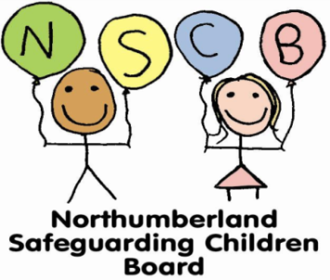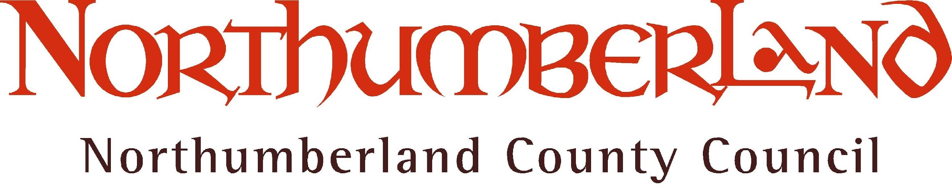
Safeguarding and Child Protection Policy Checklist (2017)
Areas to be Included | Done
The policy should state the school’s commitment to safeguarding and that it aims to create a culture of vigilance.
The policy should be clear that pupils are taught about safeguarding
Some policies may include the legislation that covers safeguarding in schools, in which case the list must be up to date.
The policy should outline the definitions, signs and symptoms of the four kinds of abuse and neglect.
The policy should include the signs and symptoms of child sexual exploitation and a reference to trafficking
The policy should include the signs and symptoms of female genital mutilation (FGM).
The policy should refer to the mandatory duty on teachers to report disclosures on FGM about a female under 18 personally to the police.
The policy should refer to so-called ‘Honour-based’ Violence
The policy should refer to Children Missing Education (CME) and the school’s approach to tackling this issue.
The policy should include the school’s duties under the Counter Terrorism and Security Act 2015 (The ‘Prevent Duty’)
The policy should reflect the fact that children with special educational needs and disabilities can face additional safeguarding challenges.
The policy should be clear about the school’s response to peer-on-peer abuse, including incidents of ‘sexting’
The policy should define 'Private Fostering' and note that there is a mandatory duty to inform the local authority of children in such arrangements.
The policy should set out the role of the Designated Safeguarding Lead
The school has at least two Designated Safeguarding Leads and these are named in the policy, along with contact details.
The school has a named governor for safeguarding who is identified in the policy, along with appropriate contact details. The policy should also name the person to whom concerns about the headteacher can be taken.
The policy is clear that staff should promptly share their concerns in writing with the DSL and sets out the procedure for doing so.
The policy should be clear that all verbal conversations should be promptly recorded in writing.
There should be an identified single location for the delivery of concern forms and a clear method for alerting the DSL that a concern form has been raised. This needs to reflect your school practice.
The policy should be clear that any concerns about the conduct of other adults in the school should be taken to the headteacher (or the Designated Safeguarding Lead); and concerns about the headteacher should go to the Chair of Governors.
In proprietor-led independent schools, concerns about the proprietor(s) to be taken directly to the local authority Designated Officer (DO).
The policy should be clear about the steps the DSL should take in order to refer a concern outside the school, eg. a social services enquiry or to the local authority Designated Officer (DO).
The policy should set out the training opportunities for staff in different roles; and the type and frequency of training.
The policy should refer to Whistleblowing
The policy should be self-contained and not rely on other documents to understand it. (Any appendices should be kept as part of the whole document.)
Links to local procedures are acceptable
The policy should have a publication date and a review date (not later than one year from publication). Typically, these dates are put on the front cover.
The policy should set out the other relevant documents all staff must have read:
- Keeping Children Safe in Education (September 2016) [Part One]; and school leaders and staff that work directly with children should also read Annex A
- School's Code of Conduct
[Although not statutory, it is useful to ask staff to be familiar with 'What to do if you're worried a child is being abused', as it contains excellent examples of the different types of safeguarding issues.]
The current safeguarding and child protection policy should be available on the school's website. Although this is not one of the DfEs statutory requirements Northumberland Safeguarding Board recommends that the policy is on the school website

