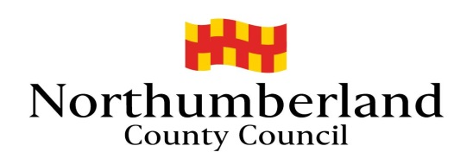
Hackney Carriages Official Fare Charges
22nd May 2023
Section 65 Local Government (Miscellaneous Provisions) Act 1976

TARIFF 1
For the first 500 yards or part thereof £2.70
For each subsequent 82 yards or part thereof 10p
Waiting time: per 30 seconds or part thereof 20p

TARIFF 2: Between 11pm and 7am and all day Sundays and Public Holidays
For the first 500 yards or part thereof £3.30
For each subsequent 65 yards or part thereof 10p
Waiting time per 30 seconds or part thereof 20p

TARIFF 3: Between 6pm on 24 December and 3am on 27 December and between 6pm on 31 December and 3am on 2 January
For the first 500 yards or part thereof £5.30
For each subsequent 82 yards or part thereof 20p
Waiting time: per 30 seconds or part thereof 40p

For non-cancellation of bookings where taxi supplied and dispatched but not required on arrival at the pick-up point the fares to be calculated from dispatch point at the tariff rates.

Tariffs 4, 5 & 6 must only be used where more than four passengers (excluding the driver) are carried in a hackney carriage licensed for that purpose.
TARIFF 4 (More than four passengers)
For the first 500 yards or part thereof £3.10
For each subsequent 82 yards or part thereof 10p
Waiting time: per 30 seconds or part thereof 20p

TARIFF 5: (More than four passengers) Between 11pm and 7am and all day Sundays and Public Holidays
For the first 500 yards or part thereof £3.60
For each subsequent 65 yards or part thereof 10p
Waiting time per 30 seconds or part thereof 20p

TARIFF 6: (More than four passengers) Between 6pm on 24 December and 3am on 27 December and between 6pm on 31 December and 3am on 2 January
For the first 500 yards or part thereof £5.30
For each subsequent 82 yards or part thereof 20p
Waiting time: per 30 seconds or part thereof 40p

Soiling Charge (except children under 14 years of age) £63.00
Dogs (excluding guide dogs) or other animal £1.10
Each item of Luggage, pram, wheeled trolley £1.10

