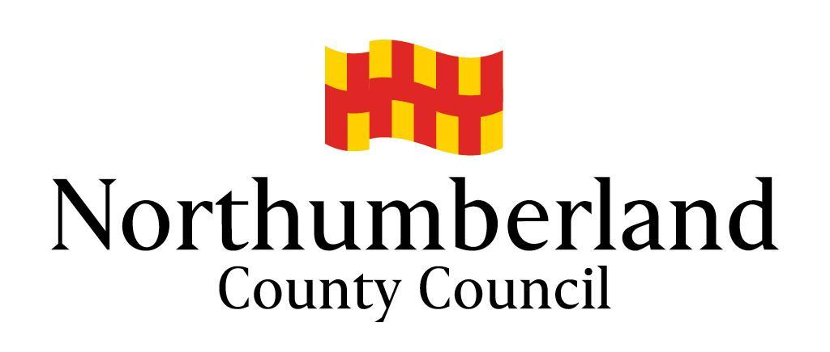
Community Chest Scheme

COMPLETING YOUR APPLICATION

We can only process your application if:

- You complete all the questions on this form; and
- You send us all of the essential supporting documents.

Please refer to the Community Chest Guidelines available on our website before completing your application.

Essential Documents:

- Completed, signed application form. An application submitted online or via email will be considered to be signed.
- Copy of Constitution/Articles of Association.
- A recent bank statement from all accounts in the name of the organisation and a copy of the most recent end of year accounts.
- If not covered within the Constitution, a separate Equal Opportunities Policy or written statement approved by your group/committee.

Where Applicable:

- Security of tenure (Freehold, or leasehold with not less than 5 years remaining).
- Licensing, including event licences and premises licence.
- Liability Insurance.
- Safeguarding policy.
- Vulnerable adult statement.
- Planning permissions.
- Evidence of at least two quotations for goods or services above £5,000.
- Any other relevant policies and procedures for working with the target community.

Supporting documents can be emailed in PDF format to communitychest@northumberland.gov.uk or by post to: Community Chest Scheme, Community Regeneration Team, Economy & Regeneration Service, Place Directorate, County Hall, Morpeth NE61 2EF.

Website: www.northumberland.gov.uk

Please detach this sheet before submitting your application form.

Community Chest  Grant Application Form | Official use only  Area  Date  Initials
ABOUT YOUR GROUP/ORGANISATION

Applicant | Group/Organisation
Name: | Name:
Address:  Post code: | Address:  Post code:
Tel: | Tel:
Email: | Email:
Position: | Web:
Please give a brief description of your group/organisation.
What is the status of your group/organisation? (Tick all that apply)
⃞ Registered Charity Charity Number: ……………………………………
⃞ Community Group ⃞ Voluntary Organisation ⃞ Tenant Association
⃞ Other, please specify: ……………………………………………………………………………………
ABOUT YOUR PROJECT

Please describe the project/activities that you plan to use your grant for.
Please tell us how you identified the need for this project/activity?

If your account balances exceed £10,000, please explain why you require external funding.
Please tell us the steps you have taken to generate or attract funding from other sources.
Who will be the main beneficiaries of the activity/project? Please give numbers, ages.
Where will the project/activity take place?
Estimated Start date |  | Estimated end date

ABOUT YOUR GRANT

Please state how much money you need for your project and what it will be used for. If you can recover the Value Added Tax (VAT) you must only show the net amount. If you are including volunteer time this must be entered in both expenditure and funding.

Items of expenditure (include all costs of the project) | Cost
Total

Please list all contributions towards your costs, including any cash, grants, volunteered time, donations, and your own resources. This must amount to not less than 25% of eligible expenditure (those items eligible for funding). The 75% maximum may be applied item by item.

All sources of funding | Current Status  (secured or pending) | Amount
Total

Amount that you are requesting (must not exceed 75% of eligible costs)

I confirm that to the best of my knowledge and belief that all the information provided is true and correct. I understand that Northumberland County Council reserves the right to recover all or part of any grant award in the event of non-compliance with the terms of the grant.

I confirm that all relevant documentation has been provided and that the group/organisation is adequately covered for all liabilities from the running of the activity/project.

I accept that Northumberland County Council, its partners, agents or employees are not liable for any costs, losses or damages incurred as a direct result of the activity or project taking place.

SIGNATURE: …………………………….…… NAME (Please print): ………………….…………….

DATE: …………………………………………..

General Data Protection Regulation 2018 Privacy Statement
Northumberland County Council is the sole owner of the information collected by us. The information collected will enable us to ​correctly process your request regarding a Community Chest Scheme application. We will not provide your personal information to any other external organisation or individual unless it is lawful to do so, eg the prevention and/or detection of crime; where sharing is covered by a data sharing agreement or Service Level Agreement (SLA); or where you have provided explicit consent to do so. However, we will need to share your information with certain departments of this Council where necessary for the Council’s law enforcement functions, eg licensing, planning enforcement, trading standards and food safety, etc. If this is the case we are not required to, and will not, seek your consent to do so. The Council’s Privacy Notice can be found on the Council’s website and at Customer Information Centres.

