Arrangements for Safe Access to County Hall in Inclement Weather
In winter months it is incumbent on all employees to take sensible precautions to minimise risks associated with their journeys to and from their place of work. These include avoiding unnecessary travel during severe weather and wearing sensible winter clothing and footwear. The Council maintains a reasonable ‘gritting plan’ to ensure safe access to and egress from places of work. The County Hall Gritting Plan is attached as Appendix 1.The plan identifies primary pedestrian routes which will be treated as a higher priority. Efforts will then be made to work on secondary routes, though prevailing conditions will influence the extent and effectiveness of such treatments. Staff must always observe the conditions and take care.
Some paths may be deemed unsafe and closed temporarily and it is, therefore, essential that colleagues follow any instructions displayed. Additionally, it should be noted that the central courtyard in Phase 1 does not form part of the fire escape route and will not be treated in inclement weather.
If staff choose to arrive very early in the morning before there has been an opportunity to treat any routes they should take account of the condition of the paths and be extra careful.
Out of Hours Working
The council has a duty of care to ensure the safety of all its employees. It is essential that employees are accounted for in the event of an emergency when working after hours. A series of incidents have occurred when staff have been locked inside the building or have activated the intruder alarm. Incidents of this nature could result in the loss of a ‘police response’ and put building attendants at risk. If you become locked in the building please ring the telephone query number on your staff pass. Your service may incur charges if attendants have to be called out in response to such incidents.

It is important that all employees observe County Hall opening times as follows:

- Monday to Thursday 6:45 am till 7.30pm
- Friday 6:45 am till 7.00pm
- Saturday 8:00 am till 11:45am

Please note that the barrier from the staff car park will be closed in line with the above closing times. Staff must exit the building prior to these times as many security passes will cease to function thereafter. Employees who choose to work on a Saturday must always sign the ‘out of hours’ book which is left on a table in the inner foyer at the main entrance.

If colleagues wish to work beyond the normal opening times they should complete an out of hours working form in advance. This is available via the front page of the intranet. When completed it should be emailed or handed to the attendants before mid-day on Thursday of the previous week to allow time for approval to be given.

If you have any queries please contact Phyllis Scott, County Hall Manager, on 622324.
Appendix 1
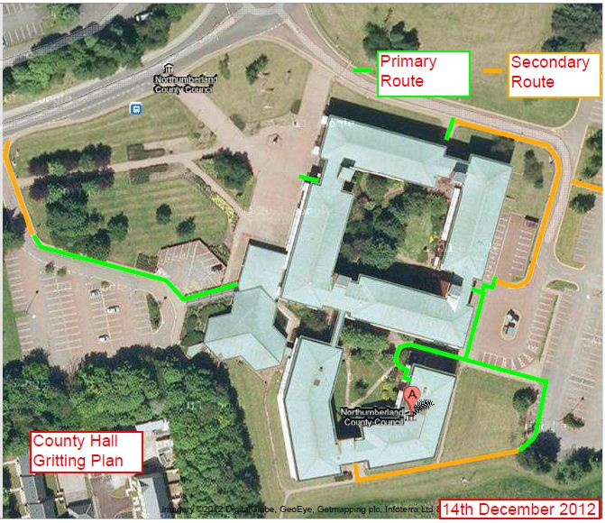

January 2013

