Relevant Legislation

The Manual Handling Regulations 1992 (as amended)

General

The moving and handling of loads has long been recognised as a major source of occupational injury and ill health. This part of the policy is principally concerned with the effective implementation of measures designed to prevent manual handling injuries to employees. It is based on the principle that staff will not undertake manual handling tasks which have the potential to cause harm, unless those tasks have, in the first instance, been risk assessed. Where the risk assessment identifies it to be necessary, prior to an activity being undertaken, appropriate training shall be provided, together with any handling and personal protective equipment.

Management Responsibilities

Managers have a responsibility for ensuring the health and safety of employees, which includes the need for safe manual handling. Managers are also responsible for ensuring that suitable risk assessments are completed and are regularly reviewed when the nature of the work changes.

Each establishment should have at least one copy of the County Council’s booklet “Good Back Guide” accessible by clicking on the intranet link for downloading/printing. The manager should ensure that each employee engaged in manual handling reads this document as part of the induction process. It is advisable that a signature be requested indicating that the employee has understood the contents when they return the booklet. A copy should also be available as a reference source, for example in a staffroom or social area.

It is the responsibility of line management to ensure that systems are in place to monitor that staff are implementing the principles of safe manual handling. Managers should also ensure that systems of work highlighted in the risk assessments are implemented.

When planning new work areas or refurbishments, consideration should be given to manual handling issues at the earliest stage.

Employees’ Responsibilities

Employees have a part to play in providing a safe environment for themselves and their colleagues. They have a duty to implement procedures and practices in accordance with their training and to follow any instructions regarding safe working practices. When using lifting equipment it is essential that the manufacturer’s instructions are followed.

Physical fitness of an individual can be an area of concern. Employees engaged in manual tasks should seek to maintain their own health and fitness at an appropriate level. All employees should report any physical limitations to their line manager. The manager may then request further advice from the Occupational Health Unit, if deemed necessary

Principles of Control

The Manual Handling Operations Regulations establish a clear hierarchy of measures to control the risk of injury, under which all employers must:

- avoid hazardous manual handling operations as far as is reasonably practicable - this may be done by redesigning the task to avoid handling the load or by automating or mechanising the process.
- make a suitable and sufficient assessment of any hazardous manual handling operation that cannot be avoided.
- reduce the risk of injury as far as is reasonably practicable. Particular consideration should be given to the provision of mechanical assistance. Where this is not reasonably practicable then other improvements to the task, the load and the working environment should be explored.

- monitor steps taken to avoid or reduce manual handling to check they are having the desired affect and, if necessary, seek alternative steps.

Staff Selection

Managers should be aware of the importance of fitness for work and that staff should be capable of carrying out appropriate handling tasks safely.

Staff fitness for work is assessed by the Occupational Health Unit using the information gained through the pre-employment screening process. For this reason, specific reference to any manual handling activities required as part of the post should be made in the job description and person specification.

The County Council operates an equal opportunities policy. However, it is still possible that for some jobs, a previous injury or ill health may prevent employment despite other positive attributes that the candidate may have. New members of staff are subject to a satisfactory health assessment and, in the event of appointment, failure to disclose information will render the employee liable to dismissal.

Assessments

Staff trained in safe handling techniques should make on the spot assessments before carrying out any manual handling tasks. A written risk assessment needs to be completed for activities which carry a significant risk of manual handling injury. This assessment will require updating whenever any relevant factors change and should be kept on file for reference purposes.

Flowchart for the initial assessment

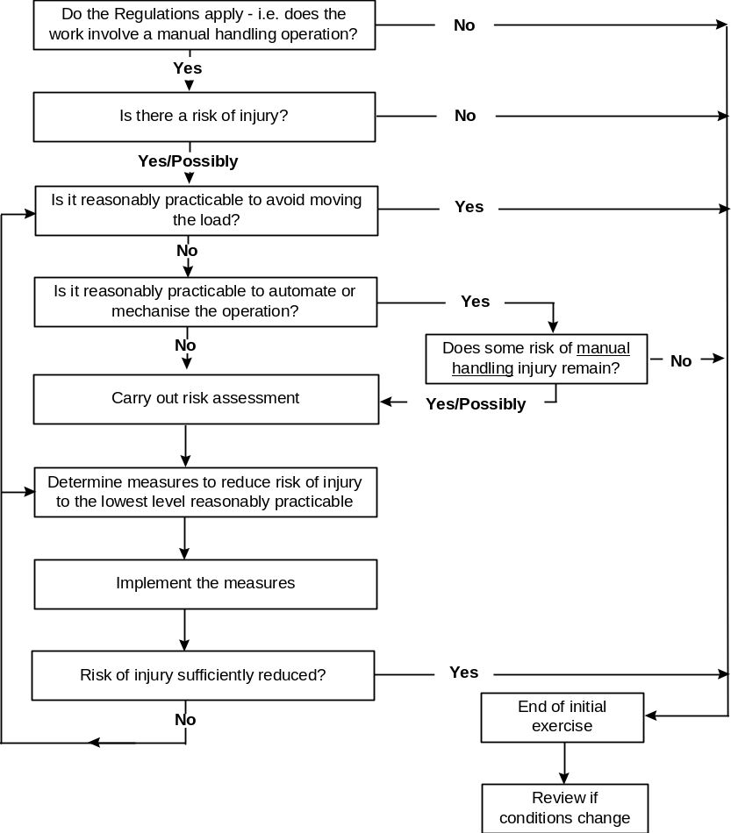
Risk assessments should be carried out by competent people who are familiar with the activity and have been trained in manual handling and risk assessment. Risk assessments for manual handling should consider the four key areas, namely, the task, the load, the individual and the environment. The corporate risk assessment forms for manual handling risk assessment can be found at the end of this section.

What to Consider When Assessing Manual Handling Risks

Task

- The nature of the task: find out how much reaching, bending, stooping, stretching and twisting is involved.

- The position of the load relative to the handler in determining the degree of control and effort required to do the task. If a load has to be lifted above head height, for example when accessing high shelves or fixing plaster-board to a ceiling, then the degree of control and effort needed will be greater than if the activity were carried out at waist height.

- The frequency and duration of the handling are important in determining the degree of risk. Where there are repetitive lifting operations combined with repeated bending, twisting and reaching over a period of time, the effect of all these tasks added together significantly increases the likelihood of injury.

Load

- The nature of the load: is it heavy, bulky, hard to grasp? The weight, size, shape and stability of the load all contribute to the degree of control and effort needed for the activity.

- When moving people there may be a risk of unpredictable movement.

Work Environment

- The nature of the working environment: is it hot, cold, windy or poorly lit? Are there slopes, uneven ground or poor access arrangements?

- Constraints on posture (such as fire fighters may experience in confined spaces or home helps working in small rooms) raise the degree of control and effort needed for the task, thereby increasing the risk of injury.

- Poor ground conditions make slips and trips more likely.

- Carrying items on slopes requires greater effort than carrying on the level.

- Manual handling should be done from a scaffold, not from a ladder.
- Placing light materials, such as roofing sheets in windy conditions, makes the manual handing task more difficult.

Individual Capability

- Does the job require someone of unusual height or strength? Does the individual have an existing health problem which increases the risk?

- Does the job put at risk someone who might be pregnant or have a disability?

- An individual’s age, strength, level of skill and experience will affect how much a person can safely handle.

- Is there a requirement for specific information or training?

Other Factors

- Where Personal Protective Equipment is used as a last resort, its implications for the risk of manual handling injury by inhibiting movement should be taken into consideration.

What to Consider When Reducing the Risk of Injury

Task

- Adopt an ergonomic approach, where reasonably practicable, by fitting the operation to the individual.

- Use of mechanical aids such as hoists, conveyors, trolleys.

- Adopt industry specific guidance.

- Improve the task layout by ensuring good positioning of storage, considering weight of load and height of storage shelves.

- Reduce the need for twisting, stooping and stretching.

- Improve the work routine

- Encourage Team handling

- Provide personal protective equipment

Load

- Make the load lighter, smaller, easier to grasp, more stable and less damaging to hold.

Work Environment

- Provide sufficient room for the operation to be carried out.

- Maintain surfaces in a good condition, properly drained and free from obstacles.

- Avoid manual handling on different levels.

- Provide a comfortable working environment

- Ensure adequate lighting.

Individual Capability

- Be aware that an Individual’s capability may be affected by previous or existing health problems.

- Provide abdominal and back support belts, where needed.

- Ensure information, instruction and training is given.

Any recommendations arising from the risk assessments should be developed into local safe working procedures.

In complex cases managers may seek advice from specialist advisors, such as in-house specialists, safety advisors, occupational therapists and physiotherapists, who will assist in making recommendations for the written assessments.

Training

Training is an important aspect in the control of manual handling activities. This enables employees to identify for themselves good and bad movement and to apply the principles of safe handling to all manual handling activities. It promotes good back care by encouraging employees to adopt a lifestyle aimed at preventing postural stress and back care injury.

Subject Areas

The following table indicates a schedule of training which should be provided as appropriate. Some of which will have to be commissioned via external providers.

Induction | For all new employees
Learning together “Manual Handling Awareness” | Statutory and Mandatory for all employees
‘Back Care’ | Awareness training for existing members of staff who do a low/moderate amount of moving and handling.
Moving Without “Tears” | Minimum training for staff that do a significant amount of object moving and handling. Basic foundation course.
Moving and transferring of service users | Complements the foundation course, and is tailored either to adults or children.
Equipment | Specific training in the use of powered mechanical lifting aids.
Refresher training | A periodic update for staff who have already attended any of the above courses.
Manual handling risk assessment | For staff with responsibility for risk assessment, this course should be completed in conjunction with “Moving Without Tears”.

Record Keeping

Training

Managers should retain information about members of staff who have received training.

Accurate records are required showing:

- signed attendance for morning/afternoon sessions
- course content, supported by literature and materials issued to course participants
- records of training with specific equipment and when it is to be used
- records of training updates/refresher training.

Most of the training courses are competency based which allows a measurement of performance at the end of the training course. A certificate of attendance will be issued on completion of the relevant course.

Manual handling training may be provided by external organisations which deliver training on the County Council’s behalf and are qualified to appropriate standards. Establishments which do not use the recognised providers must verify that the trainers are qualified to an appropriate standard.

Arrangements within Each Division

In accordance with current legislation and Northumberland County Council’s Corporate Health and Safety Policy Statement all Divisions within the County Council must devise and implement procedures to ensure the following objectives are achieved:

- identify manual handling hazards.

- identify measures required to avoid the need for manual handling operations.

- assess the risk from manual handling operations that cannot be avoided.

- provide information, instruction and training.

In order to achieve the above objectives the relevant Director is responsible for ensuring that suitable and sufficient arrangements are made to fulfil the requirements detailed below:

- Assign Responsibilities

Identify the relevant Managers/Supervisors responsible for ensuring arrangements for safe manual handling are in place. Ensure they are aware of their responsibilities in this regard and that they are competent to discharge them.

- Assess the risks.

Managers/Supervisors responsible for controlling employees’ exposure to manual handling hazards must:

- Undertake a general assessment of risks from the task.

- Where a general assessment indicates the possibility of injury and avoidance of the task is not reasonably practicable, carry out a more specific assessment. This must take into account the specific factors; task, load, working environment, individual capability and any other factors that need to be considered.

- Where assessment identifies it introduce working practices and/or equipment to reduce the risk to its lowest level.

- Record the assessment.

- Review the risk assessment when there is reason to think it is no longer valid.
- Training and Competence.

Managers responsible for controlling employees’ exposure to manual handling hazards must:

- Be competent to do so.

- Ensure those supervising or completing the work are competent to do so.

- Consult with employees and allow their participation.

- Give employees information, instruction and training about the risks, control measures and safe working procedures.

Managers should make sure that all members of staff are considered when carrying out risk assessments for moving and handling tasks. Managers should examine their training requirements carefully. The table below may provide help with this analysis:

Staff member | Training Course
Staff with the responsibility for carrying out risk assessments for manual handling activities. | ‘Manual handling risk assessment’ course
All staff who engage in regular manual handling. | ‘Moving without tears’ course
All staff who engage in regular manual handling. | Learning together “Manual Handling Awareness”
Staff who are involved with limited amounts of manual handling. | ‘Back Care’ awareness course

Discussions should be held with the Training and Organisation and Development Section within County Hall.

The following documentation should be used to make a formal record when carrying out manual handling risk assessments.

Manual Handling Risk Assessment (General) – Form and Guidance

The standard risk assessment form, supplemented by the pictograms on the next page, should be completed for manual handling tasks where there is a potential risk of injury arising from lifting or handling an object. This should detail the job description of the employee and give a detailed description of the operations covered by the assessment.
MANUAL HANDLING RISK ASSESSMENT
(to be completed in conjunction with the standard Risk Assessment Form – RA1)

Directorate: | Premises: | Activity:
Materials to be handled | Hazardous Contents: | Locations:
Can manual handling be eliminated?

DETAILED ANALYSIS Mark boxes as appropriate. Every activity must be marked

 | 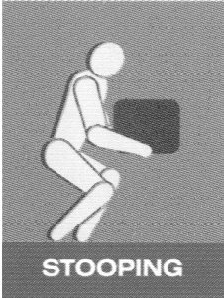 | 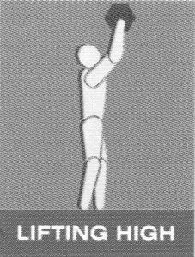 | 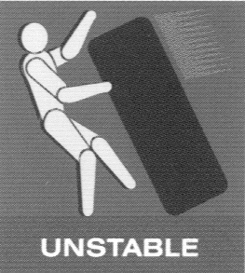  UNPREDICTABLE  LOAD MOVEMENT | 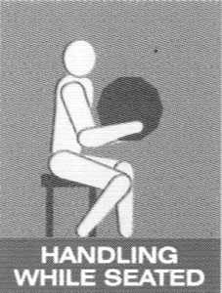 | 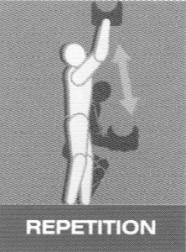 | 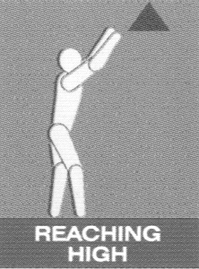 | 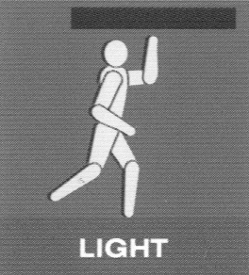  IMPOSED WORK  RATE | 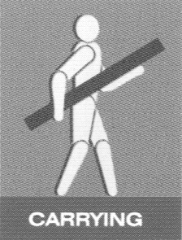 | 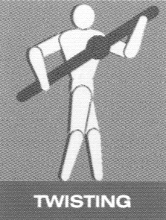 | 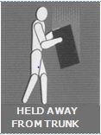 | 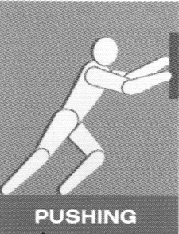 | 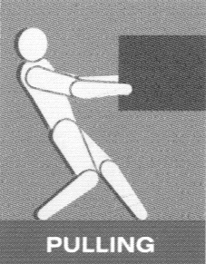
 | Yes □ No □ | Yes □ No □ | Yes □ No □ | Yes □ No □ | Yes □ No □ | Yes □ No □ | Yes □ No □ | Yes □ No □ | Yes □ No □ | Yes □ No □ | Yes □ No □ | Yes □ No □

 | 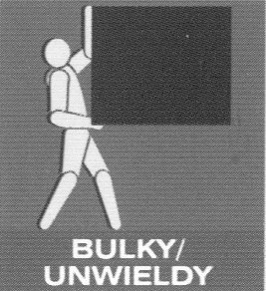 | 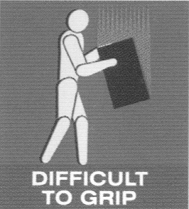 | 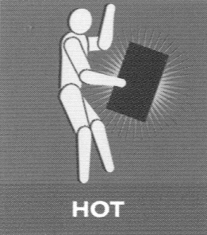 | 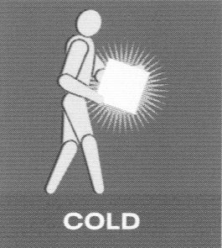 | 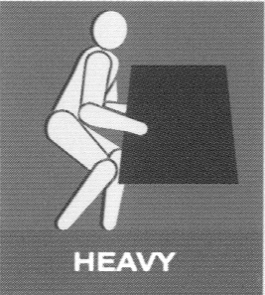 |  | 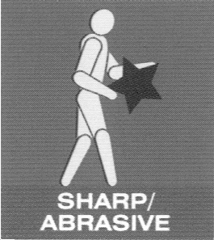 |  | 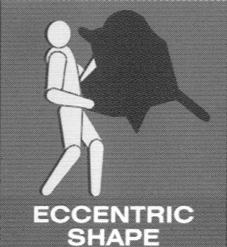
 | Yes □ No □ | Yes □ No □ | Yes □ No □ | Yes □ No □ | Yes □ No □ | Yes □ No □ | Yes □ No □ | Yes □ No □ | Yes □ No □

 | 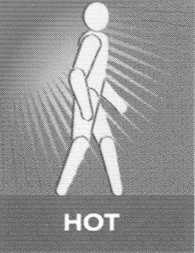 | 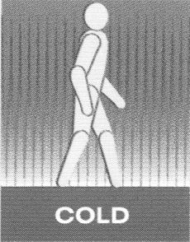 | 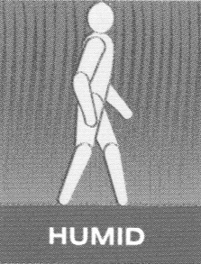 | 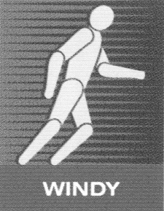 | 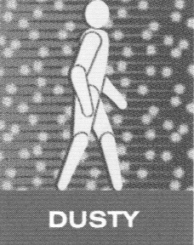 | 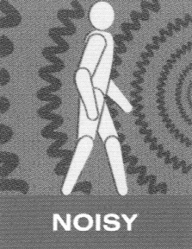 | 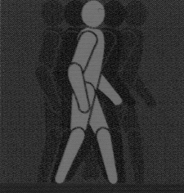  POOR  LIGHTING | 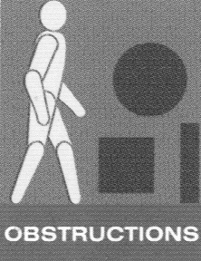 | 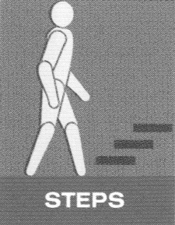 | 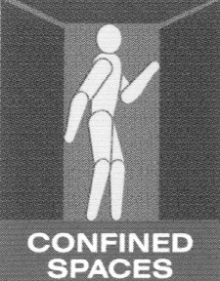 | 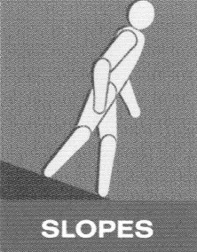 | 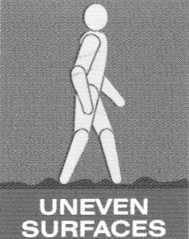
 | Yes □ No □ | Yes □ No □ | Yes □ No □ | Yes □ No □ | Yes □ No □ | Yes □ No □ | Yes □ No □ | Yes □ No □ | Yes □ No □ | Yes □ No □ | Yes □ No □ | Yes □ No □

OVERALL ASSESSMENT OF THE RISK OF INJURY?

Low / Med / High*
 | 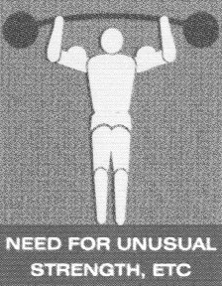 | 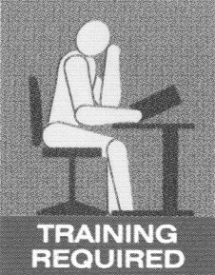 | 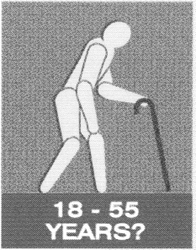 | 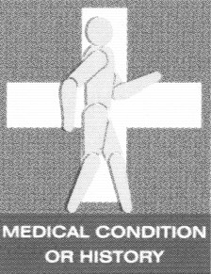 | Insufficient rest or recovery Yes □ No □  Other Factors  Hazard during pregnancy Yes □ No □  Movement hindered by PPE Yes □ No □
 | Yes □ No □ | Yes □ No □ | Yes □ No □ | Yes □ No □

REMEDIAL ACTION TO BE TAKEN:

Remedial steps that should be taken, in order of priority (continue on separate sheet if necessary) | Action by date:
 | Reassessment date:
 | Assessor’s name:
 | Signature:

