 | COSHH Risk Assessment No: |  |  |  |  |  |  |  |  |  |  |  |  |  |  |  |  |  |  |  |  |  |  | 
Department: |  |  |  |  |  |  |  |  |  |  |  |  |  |  |  | Establishment/Team:
Name of substance, manufacturer and safety data sheet reference.
Describe the activity or process

(Include how long and how often this is carried out and the quantity of substance used. A copy of a current safety data sheet (SDS) for the substance should be attached to this assessment and cross-referenced when completing it).
Specify where the activity or process is being carried out
Identify the persons at risk: |  |  |  |  |  |  |  |  | Employees  (including trainees) |  |  |  |  |  |  |  |  | Contractors |  |  |  |  |  |  | Public  (including students)
Hazard(s)
Physical Nature of Hazard - SDS Section 9.1
Liquid |  | Dust |  |  |  |  | Solid | Fume |  |  |  |  |  | Mist |  |  | Vapour |  |  |  |  | Gas |  |  |  |  |  | Other (state) _________
Classification of Hazard - SDS Section 2.2
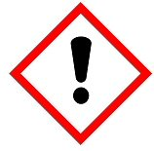  Moderate hazard |  |  | 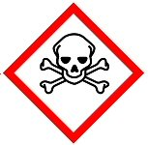  Acutely toxic |  |  | 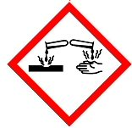  Corrosive |  |  | 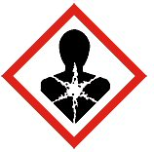  Health hazard |  |  |  | 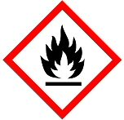  Flammable |  |  |  | 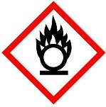  Oxidising |  |  |  | 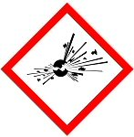  Explosive |  |  |  |  |  | 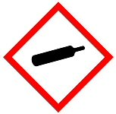  Gas under pressure |  | 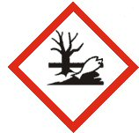  Harmful to the aquatic environment
Risk(s)
Signal Word - SDS Section 2.2  Warning Danger |  |  |  |  |  |  |  | Add Hazard Statement(s) - SDS Section 2.2
Route of Exposure - SDS Section 2.2
Inhalation |  |  |  |  | Ingestion |  |  |  |  | Skin Contact |  |  |  |  |  |  |  |  | Contact with Eyes |  |  |  |  |  |  | Other (state)_________
Risks to Health – Most Important Symptoms and Effects - Refer to safety data sheet (attached) SDS Section 4.2
Workplace Exposure Limits (WELs) please indicate n/a where not applicable - SDS Section 8.1
Long-term exposure level (8hrTWA): |  |  |  |  |  |  |  |  |  |  |  |  |  |  | Short-term exposure level (15 minutes):
Control Measures: (for example extraction, ventilation, training, supervision) - SDS Section 8.2
First Aid: Recommended Actions - SDS Section 4.1
Inhalation:

Ingestion:

Skin Contact:

Contact with Eyes:

Other: n/a

Is health surveillance or monitoring required? Yes No

Personal Protective Equipment (state type and standard) - SDS Section 8.2
Dust Mask |  |  |  |  |  |  |  |  |  |  |  |  |  |  | Visor
Respirator |  |  |  |  |  |  |  |  |  |  |  |  |  |  | Goggles
Gloves |  |  |  |  |  |  |  |  |  |  |  |  |  |  | Overalls
Footwear |  |  |  |  |  |  |  |  |  |  |  |  |  |  | Other
Storage Arrangements - SDS Section 7.2
Disposal of residual waste and Containers - SDS Section 13.1 and guidance
Hazardous Waste Skip Return to Depot Return to Supplier Other (state)

(If Other Please State):
Firefighting measures, accidental release measures, toxicological information and ecological information are provided in the safety data sheet (attached).

Is exposure adequately controlled? |  |  |  |  |  |  |  |  |  |  |  | Yes No
Risk Rating After Implementation of Control Measures (see guidance)
High Medium Low
Assessed by: |  |  |  |  |  |  |  |  |  |  | Date: |  |  |  |  |  |  |  |  |  |  |  | Review Date:

